**Segmenting and clustering New York City and find best location for new Pharmacy using IBM Watson studio and foursquare website.**

**Nada Abouebeid**

**July 25, 2020**

* 1. **Introduction**

## New York City, is the most populous city in the United States. With an estimated 2019 population of 8,336,817 distributed over about 302.6 square miles (784 km2), New York City is also the most densely populated major city in the United States. Located at the southern tip of the U.S. state of New York, the city is the center of the New York metropolitan area, the largest metropolitan area in the world by urban landmass. [1]

* 1. **Problem**

Due to the increased demand, the interest of entrepreneur to open medical investment project in New York has increased drastically. Which led to the large number of health centers and medical offices in all parts of the city. This fact is why it is so difficult to find the right locations to open new medical office. In this project I am focusing on finding the best locations in the city to open new community pharmacy. Many factors we should keep in our mind before choosing any location.

## 1.3. Key points to Pick the Best Pharmacy Location

Deciding where to locate is one of the first major choices you'll make while building your pharmacy business. Based on article for Mr. Lester Nathan, MS in Pharmacy times journal-2015-09-14. He stated that ‘’The location you choose for your pharmacy will highly contribute to its success or demise’’.

**The Key points:**

1-Adjacent to an upscale residential area

2-Next to a chain store pharmacy

3- Nearby medical arts building

If these characteristics are not simultaneously available, then always go with the first: being in or near an upscale neighborhood. An alternate approach is to be on or close to a highway that connects high-income families to your store. Mr. Lester Nathan stated ‘’positioning the pharmacy inside a medical building is bad today’’. But being around medical building has positive impact as it increases number of interested patients and customers.

Being in a shopping mall, or free-standing building is good, but being next to a chain store like CVS, Rite Aid, or Walgreens is the best. This has been validated by research from MIT’s famous Sloan Management School. Your sales will increase because the chain stores bring in people who are mainly there to find something to aid their maladies. These people will notice how different you are as long as you truly differentiate yourself.[2]

* 1. **Interested**

Our Stakeholder are entrepreneur who want to invest in healthcare facilities especially retail or community pharmacy. As demand sharply increased during the current Covid-19 pandemic. Finding the best location can make the difference in tens of thousands of dollars in high-margin sales.

**2. Data acquisition and cleaning**

**2.1 Data sources**

The Data we are using in this project collected from NYC Open Data website. It presents all the healthcare facilities in NYC till July 3, 2019. I decided to fix one of the factors to find the location. So, I chose to fix being nearby medical buildings in this project. It is helpful to limit the options and to grantee the foot flow of interested customers ‘patients.

**2.2 Data cleaning**

The data cleaned and tabled in pandas. Separated the longitude and latitude to prepare the folium map with dot markers of the 60 facilities locations in NYC map.

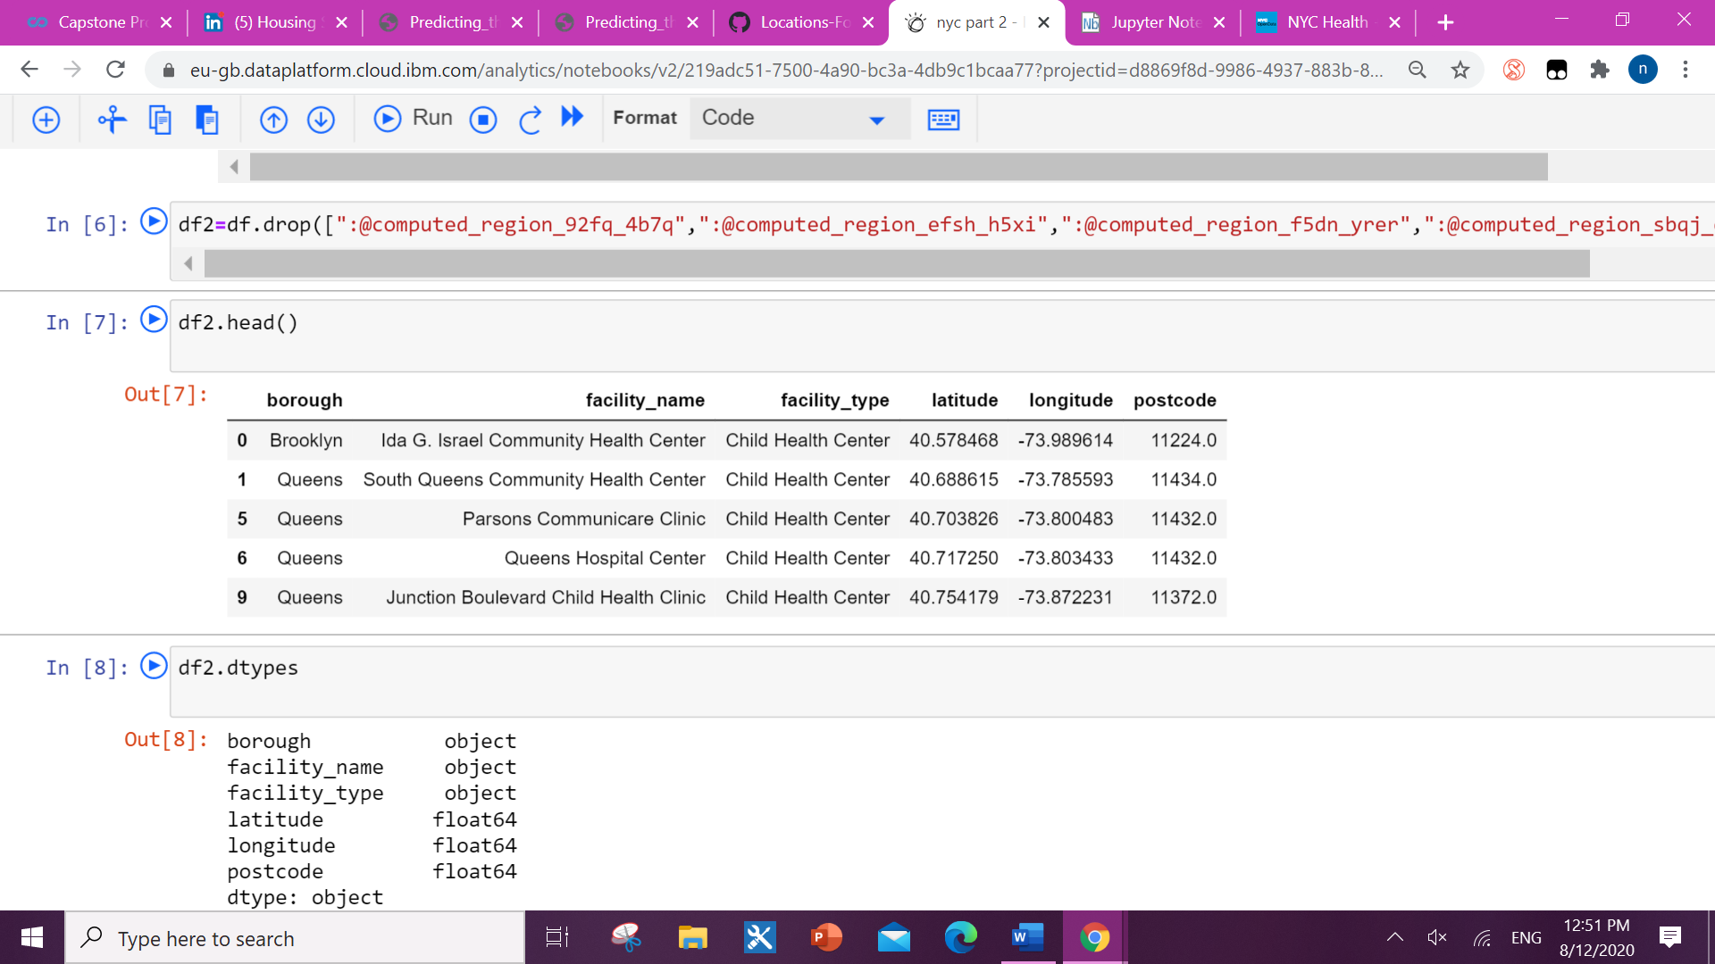

after finding the geographical coordinate of New York City (40.7127281, -74.0060152) we visualize it in folium map

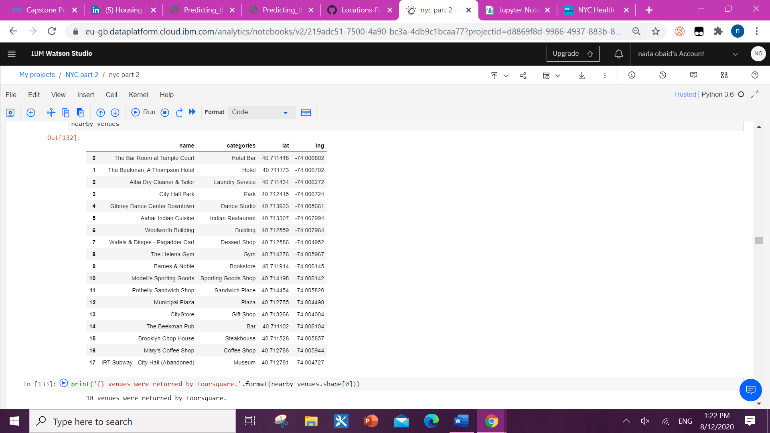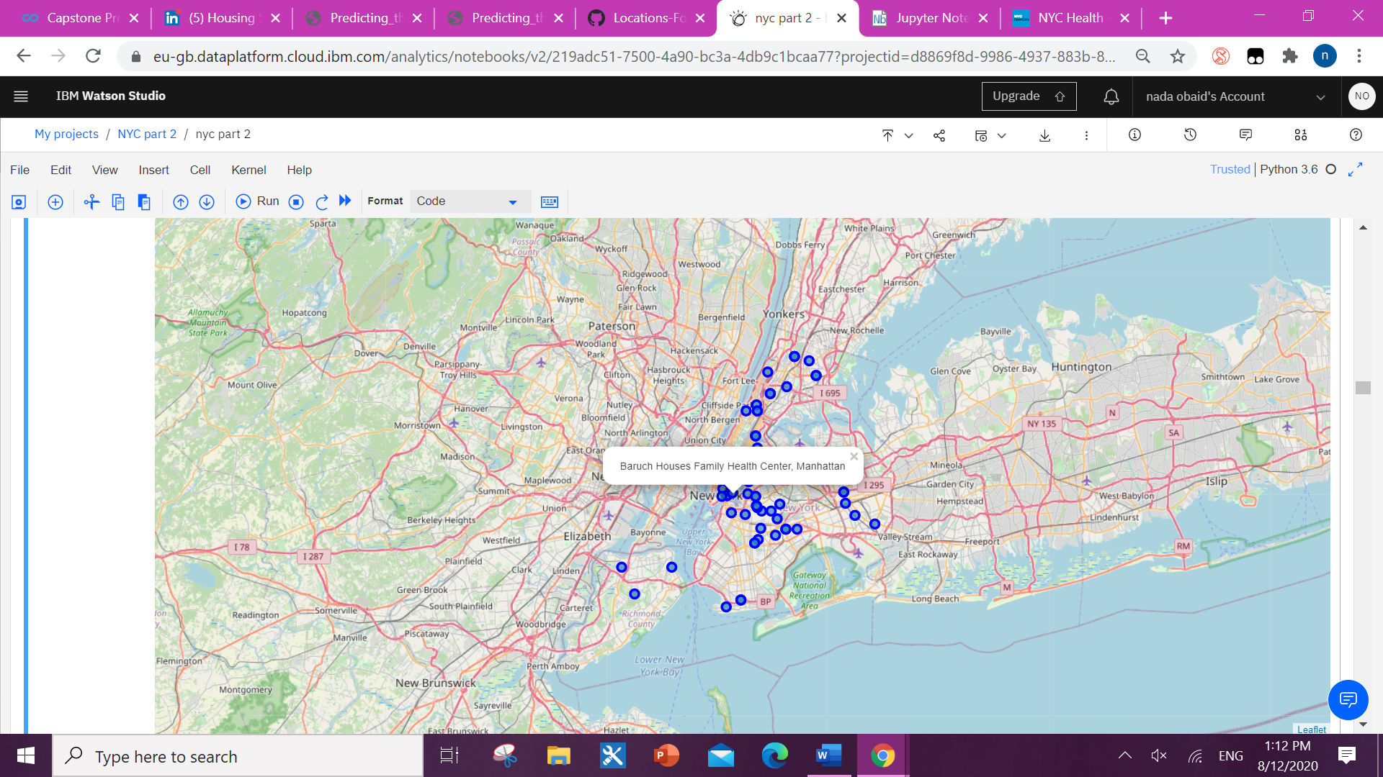

We used foursquare API to study the venues up to 200 meters away from the healthcare facilities marked on the map. The collected data cleaned and presented in tables with latitude and longitude.

In summary of this table **238** unique categories were returned by Foursquare, then I created a table which shows list of top 10 venue category for each borough in below table.

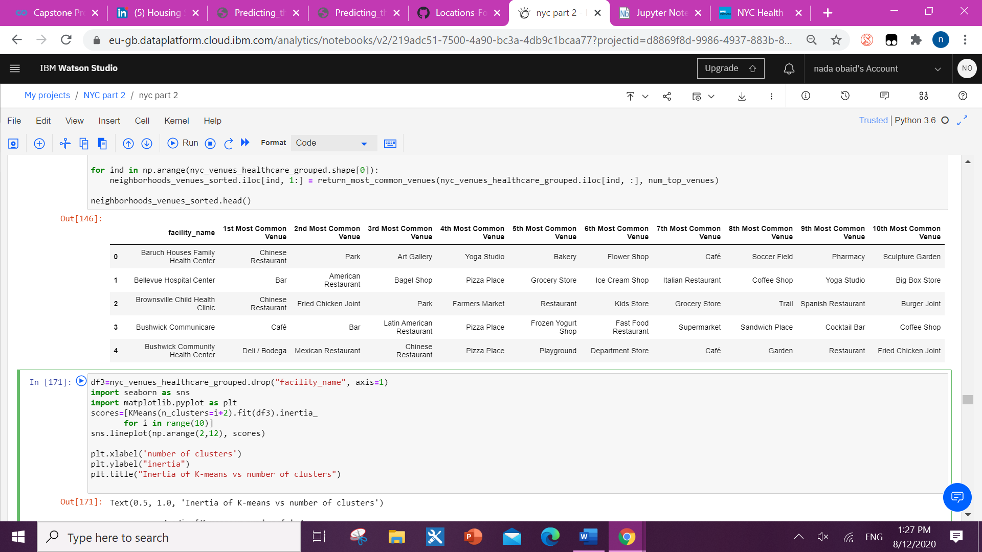

**3. Machine learning and clustering**

I got some common venue categories. In this reason I used unsupervised learning K-means algorithm to cluster the healthcare facilities locations. K-Means algorithm is one of the most common cluster methods of unsupervised learning.

**3.1. K-Means and elbow method**

First, will run K-Means to cluster the boroughs into **5 clusters** because when I analyze the K-Means with elbow method it showed me around 6 degrees

for optimum k of the K-Means. 5 clusters quite enough to understand the similarities between the clustered locations.

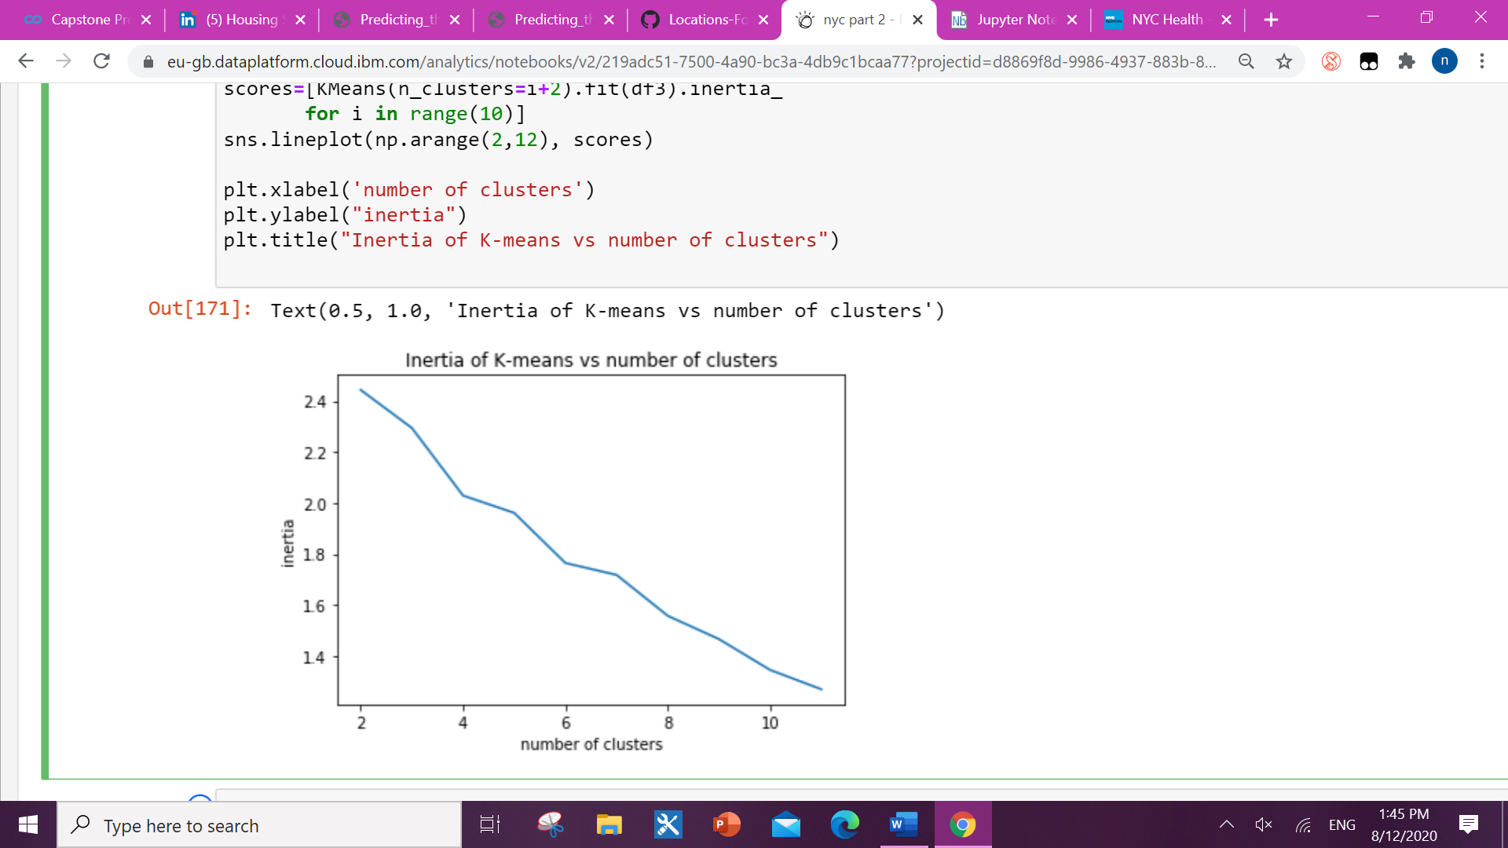

**4. Results**

Here is my merged table with cluster labels for each borough.

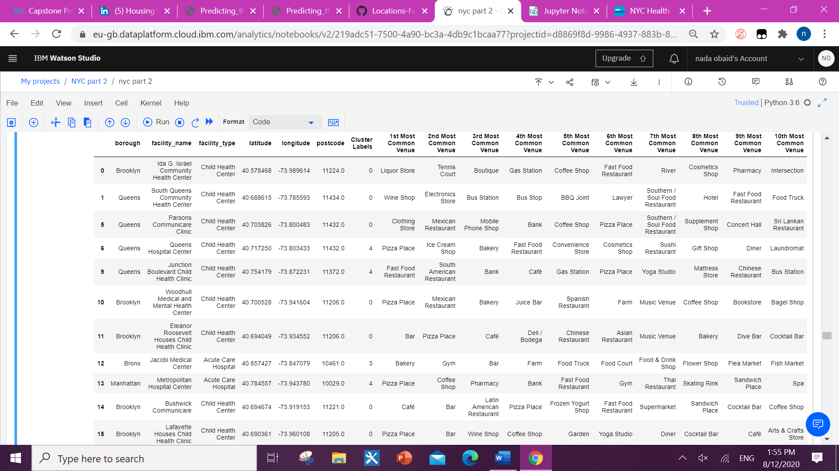

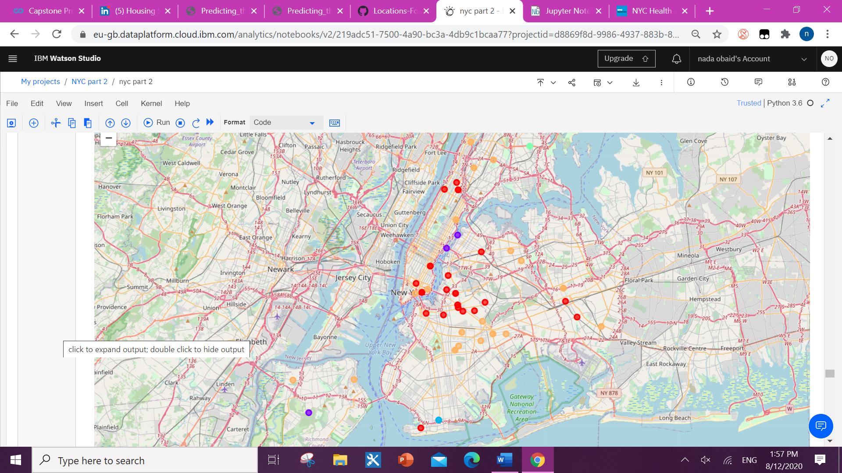This is a folium map showing the locations in 5 different color mark each for one cluster.

**4.1. clusters tables and bar charts**

**Cluster 0:**

**Cluster 0 analysis discussion:**

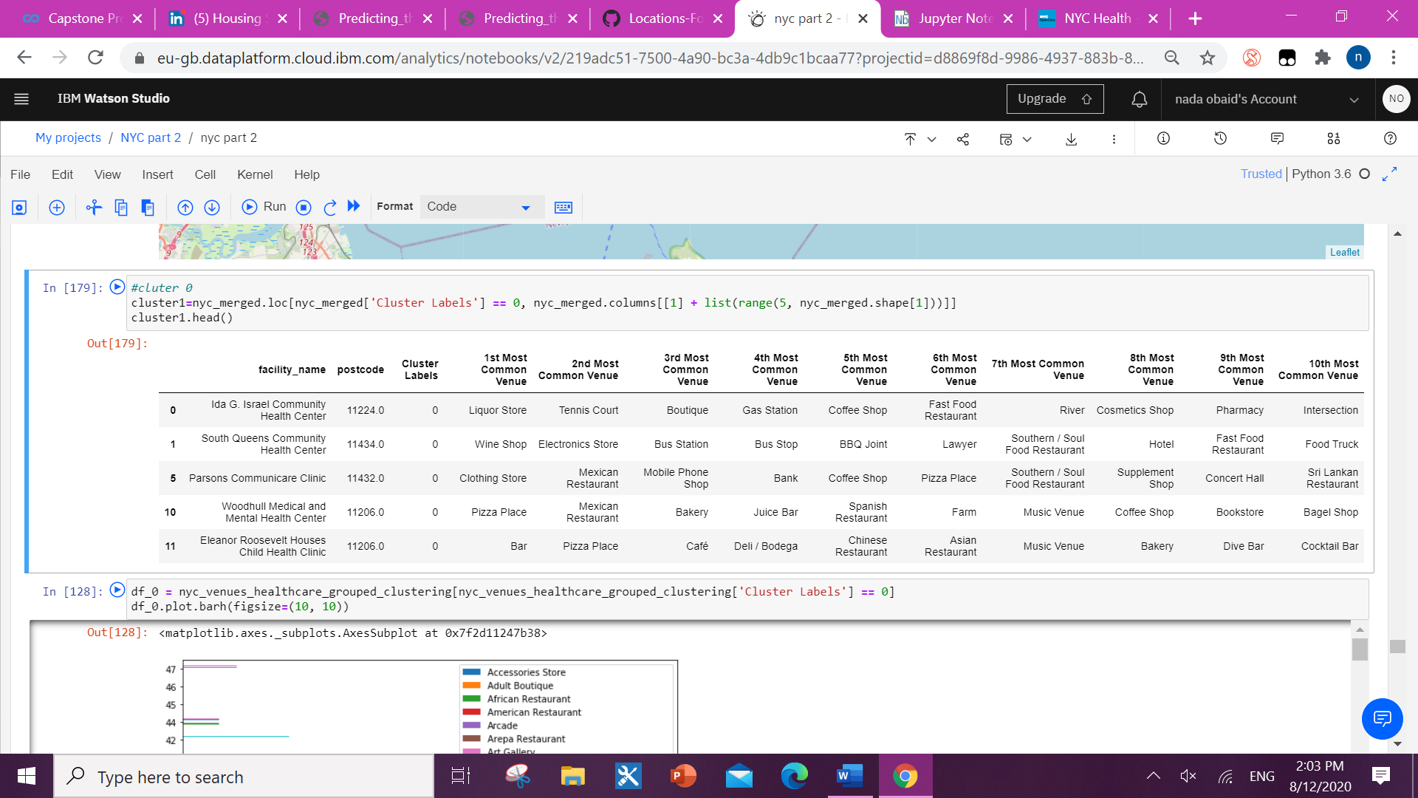no pharmacies but has shopping options and cafes around the areas of the healthcare facilities, but no competitors around. It needs location analysis and feasibility study.

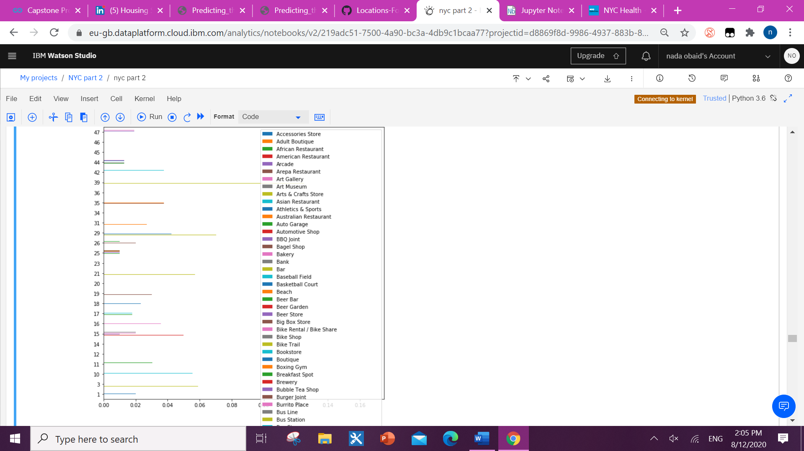

Facility number

Venues

Venues nearby facilities in cluster 0

**Cluster 1:**

Cluster 1 analysis discussion:

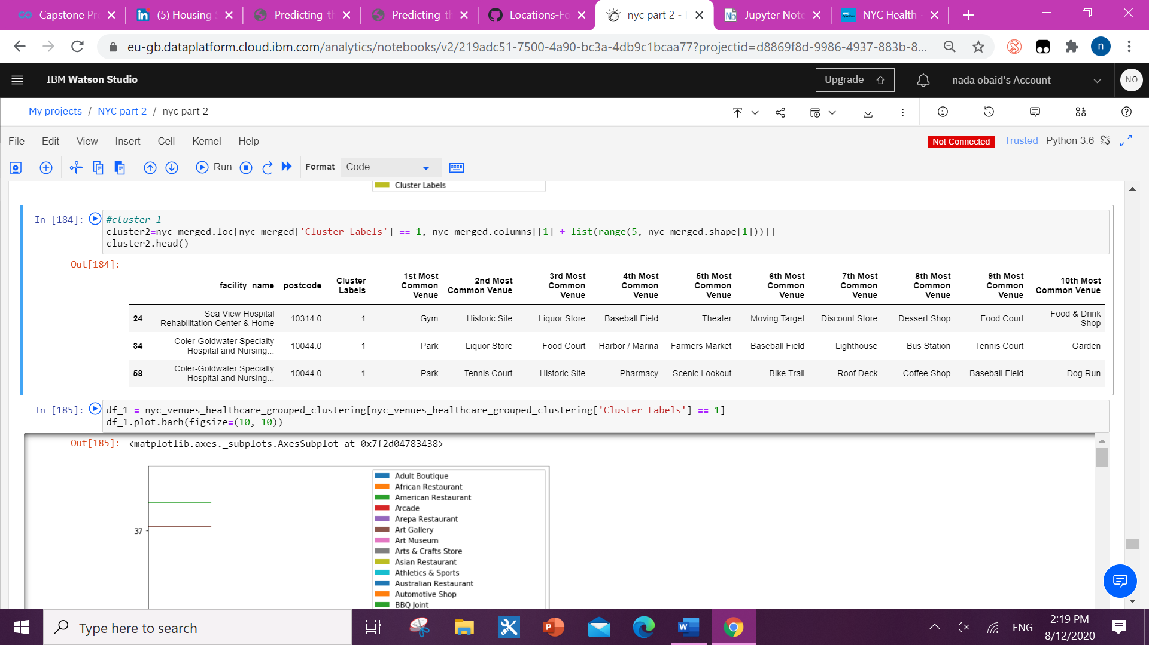outdoor activities areas - residential areas good option for new community pharmacy location which basically focus on regular patients. Needs population income study to assure the higher income patient reaches to the location

.

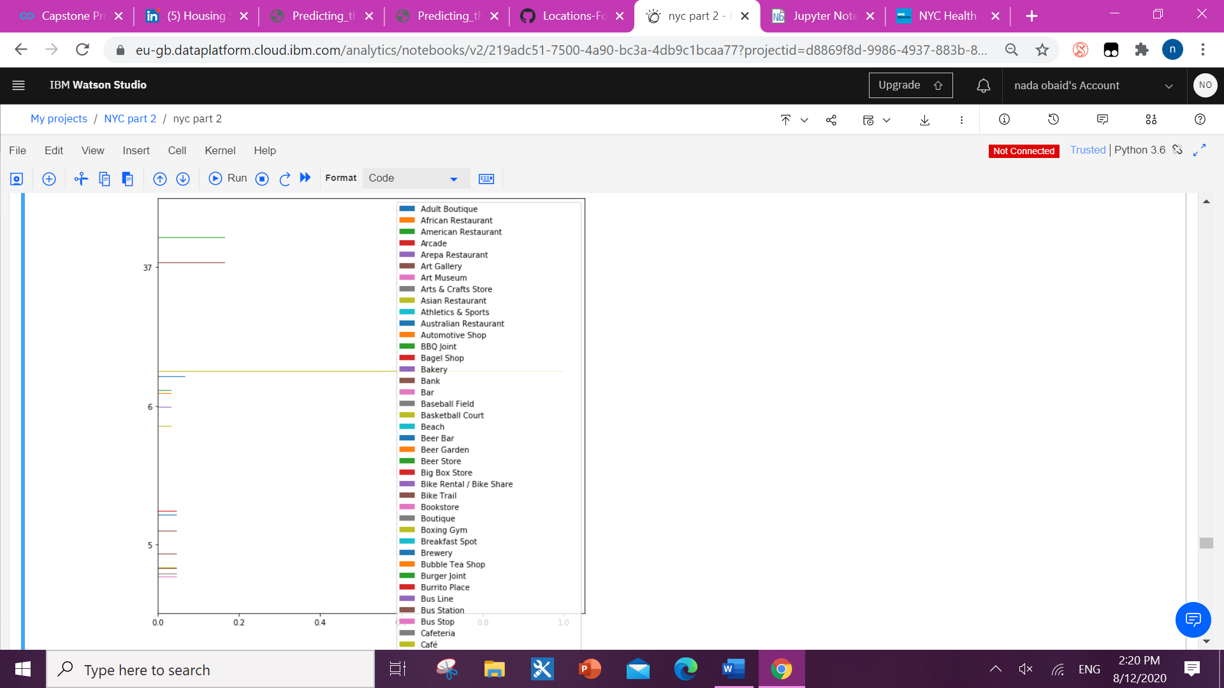

Facility number

Venues nearby facilities in cluster 1

Venues

**Cluster 2:**

**Cluster 2 analysis discussion:**

expats residential areas - Asian minorities residential areas. not what we are aiming for as we focus on higher income population areas and mixed population more favorable for any business.

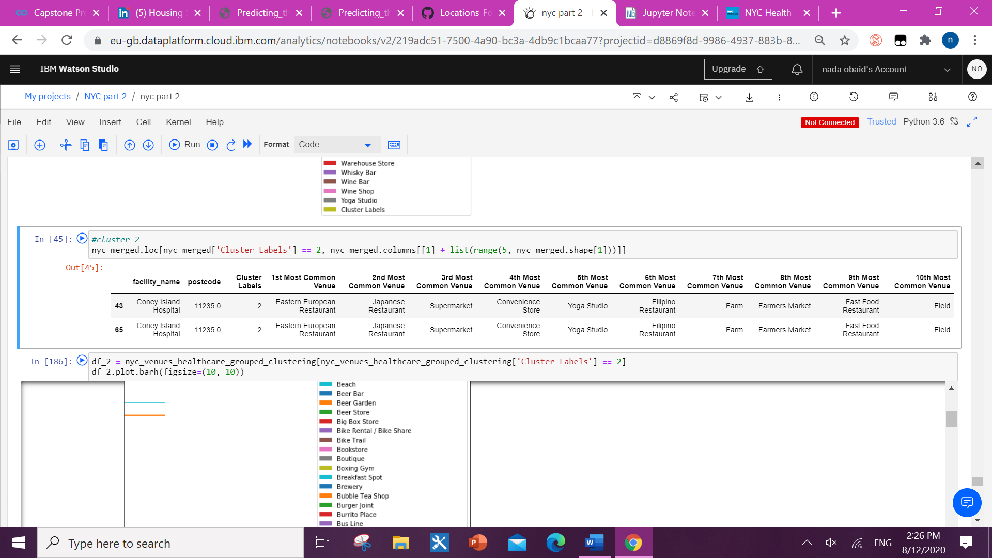

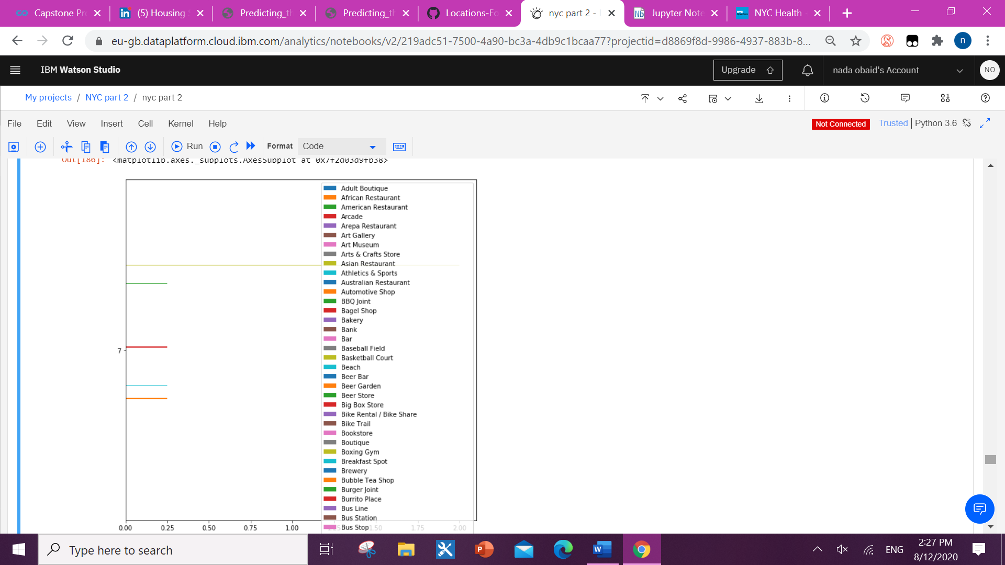

Facility number

Venues nearby facilities in cluster 2

Venues

**Cluster 3:**

**Cluster 3 analysis discussion:**

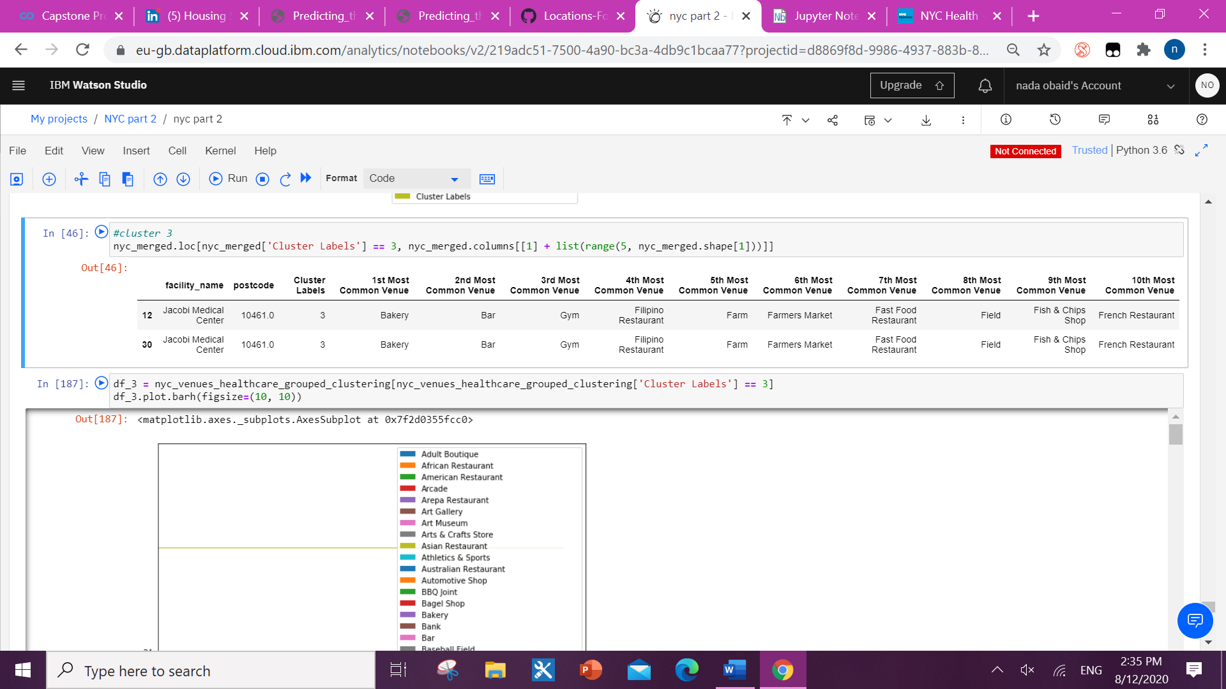farmer market and supermarket areas - household facilities. classic option for new community pharmacy as it will assure the foot flow to the store without too much effort to advertise the location. but no competitors nearby the healthcare facilities

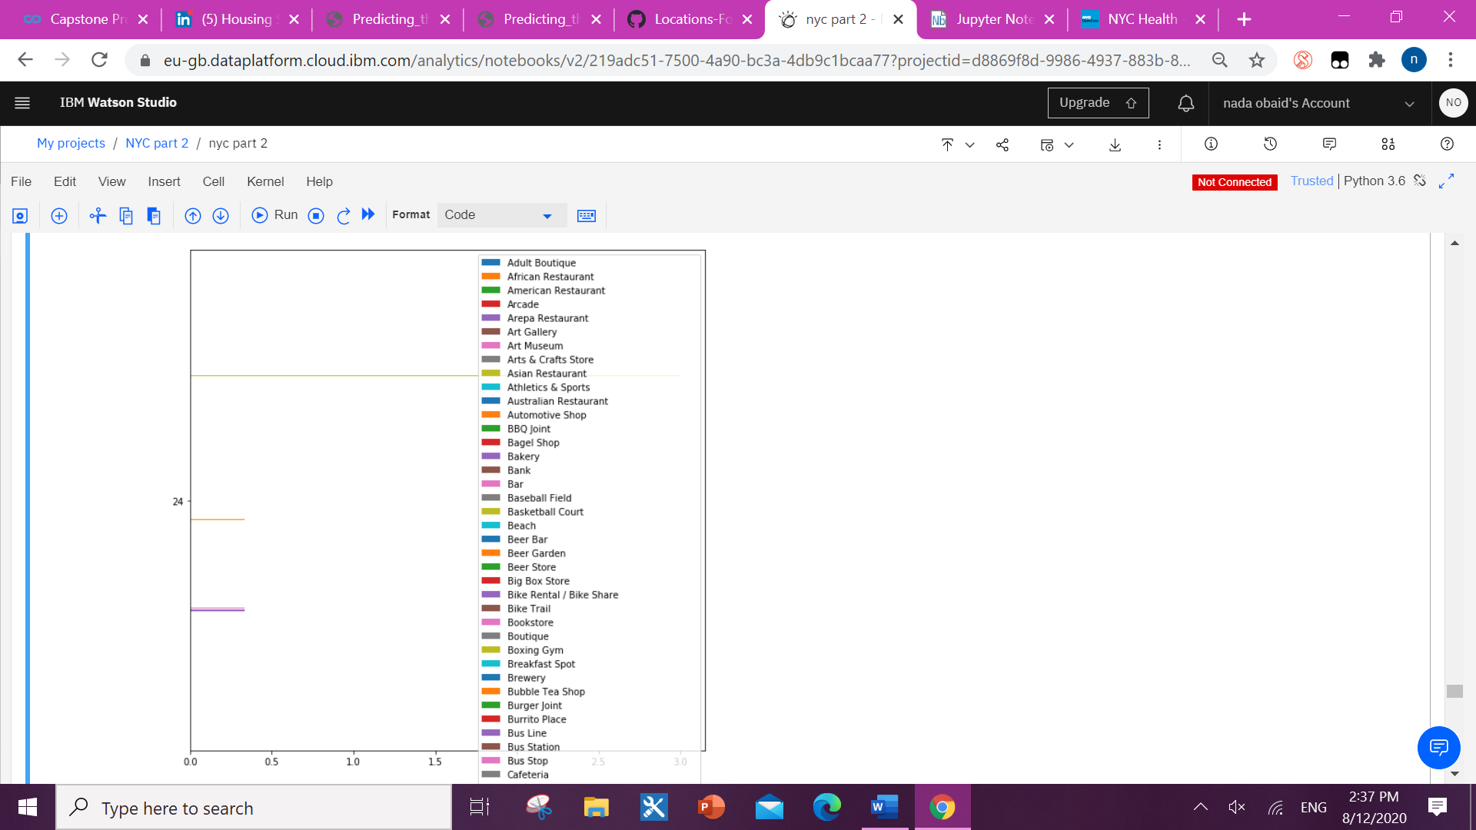

Facility number

Venues nearby facilities in cluster 3

Venues

**Cluster 4:**

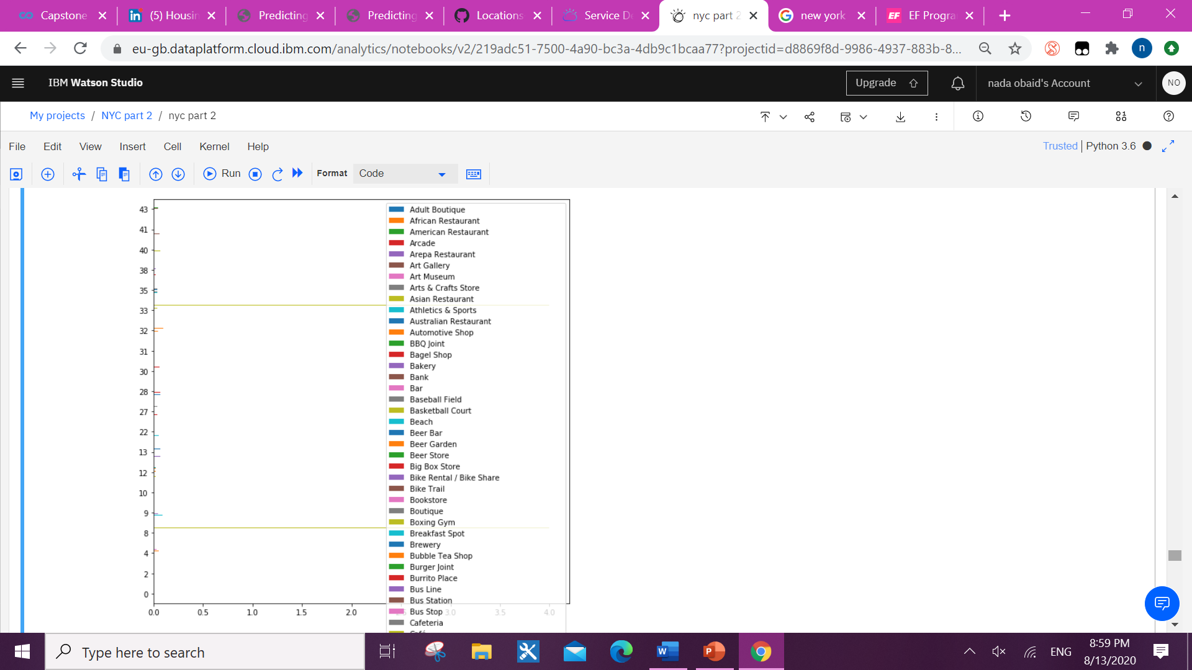

Facility number

Venues nearby facilities in cluster 4

Venues

Cluster 4 analysis discussion:

 it is the ideal areas to open new pharmacy as the are many factors to grantee the foot flow like the household and personal shopping facilities, variety of restaurants and cafes, gym and the most important is the great availability of the competitor pharmacies around the health centers.

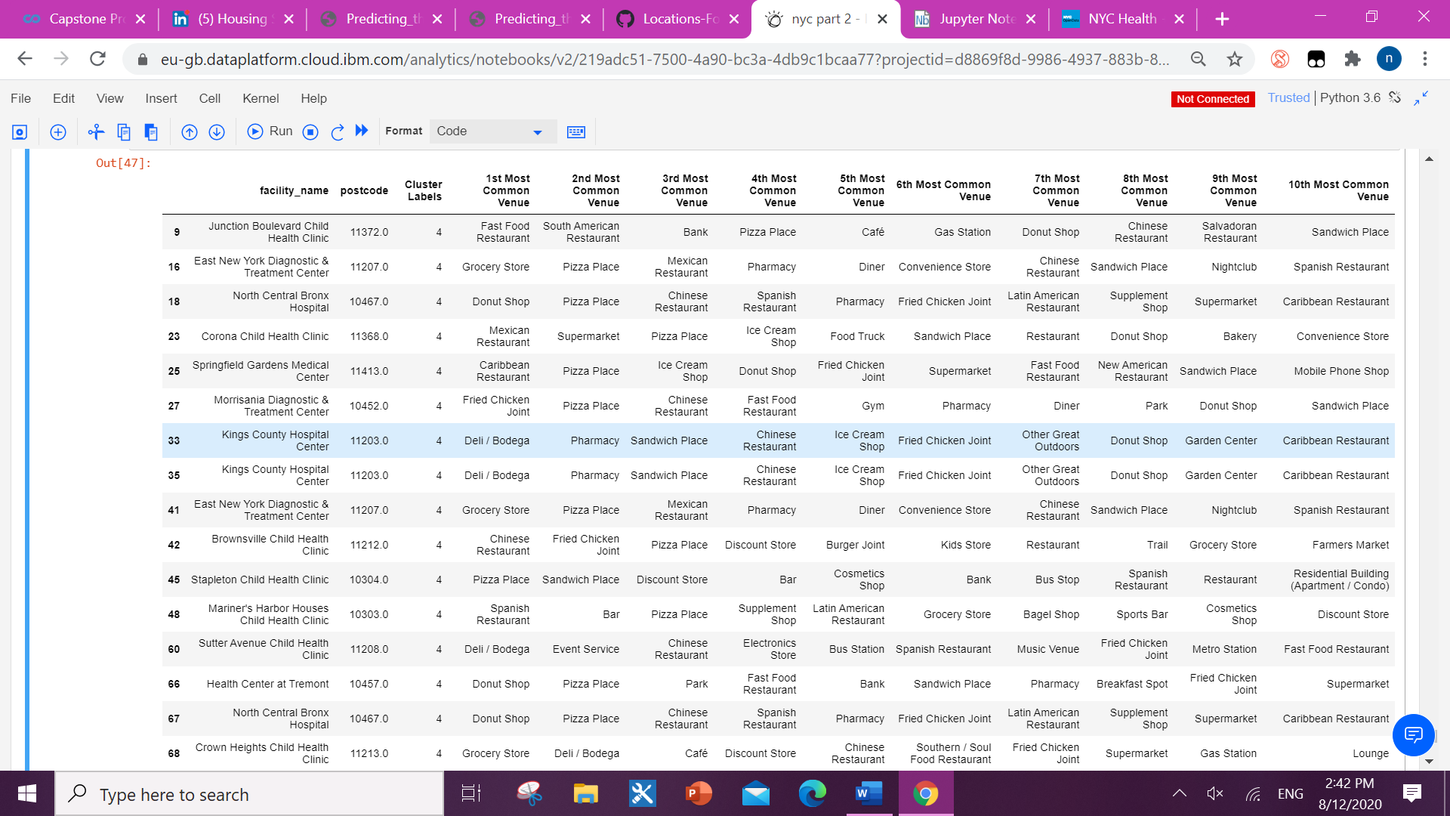

**5. Discussion:**

After clustering the locations based on the nearby venues, we found that cluster 4 has met most of the key points we discussed earlier in the introduction.

Cluster 4 has locations of healthcare facilities which are located in active areas with shopping malls, restaurants, household shopping and gyms. We will diversity of people based on age, culture and most importantly salary income.

Foot flow confirmed.

So, remaining for us to locate the availability of pharmacy especially big chain pharmacies to place our name in between them.

For that I filtered the facilities location in cluster 4 based on the availability of ‘Pharmacy’ venue nearby and what we got 12 locations out of 64 locations of healthcare facilities in NYC.

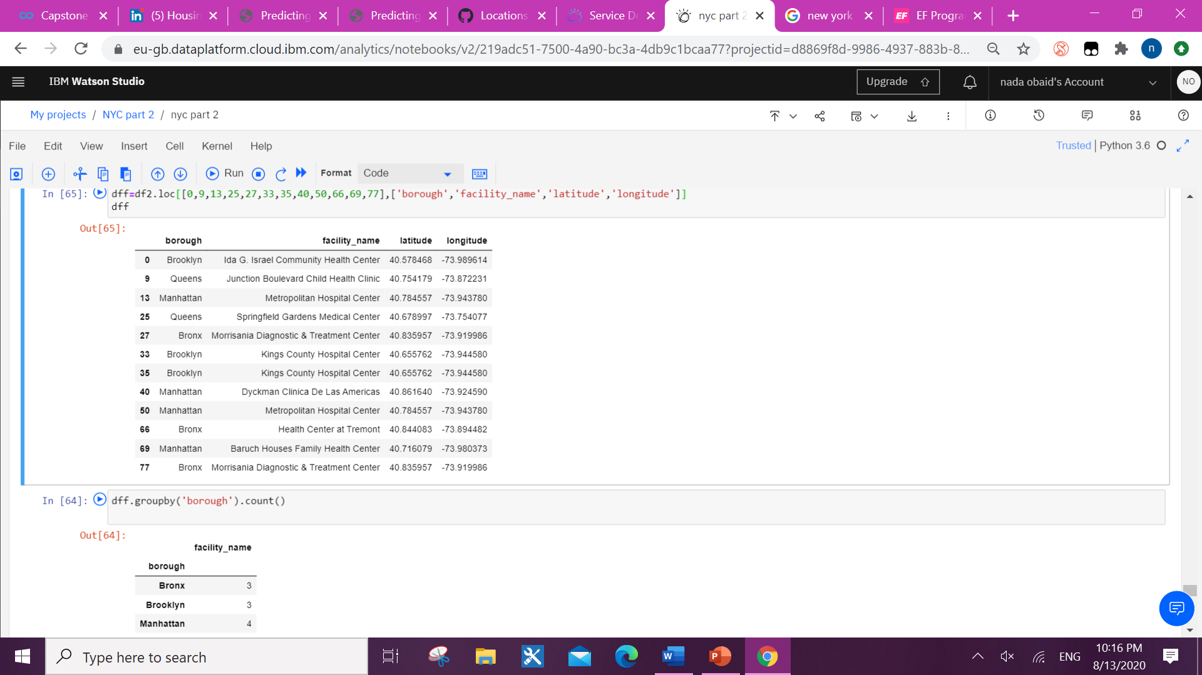These locations are located mostly in 4 different boroughs of the city. We got 3 locations in Bronx and Brooklyn, 4 in Manhattan, and 2 in queens.

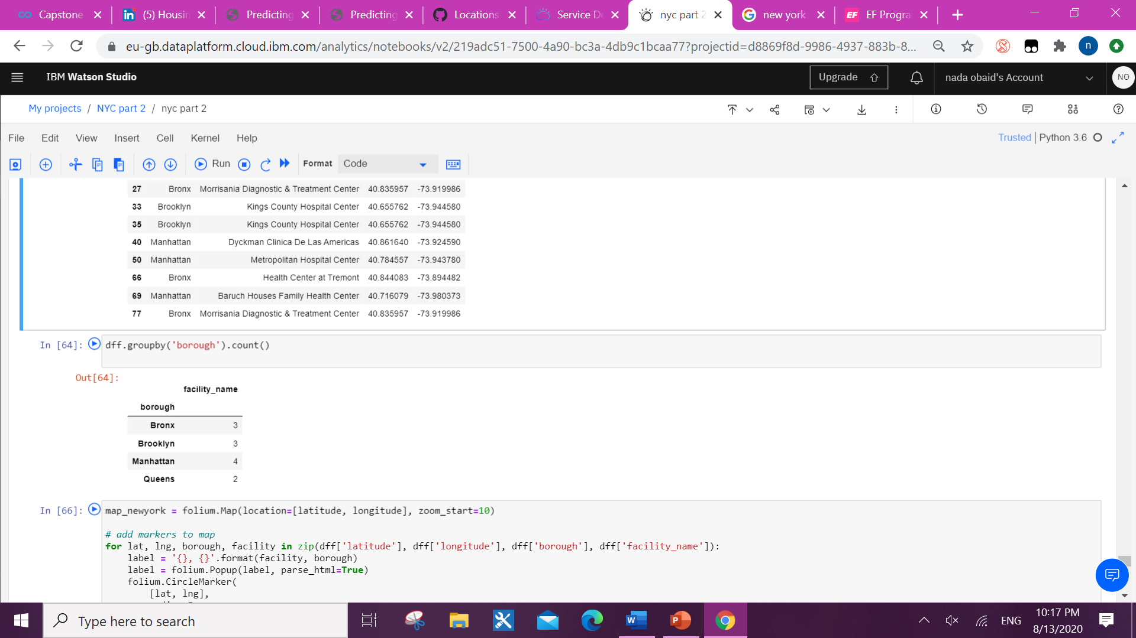

Finally located the 12 location on my NYC folium map with markers and we are ready to do feasibility study for each location based on many other different factors like tenant location and price. 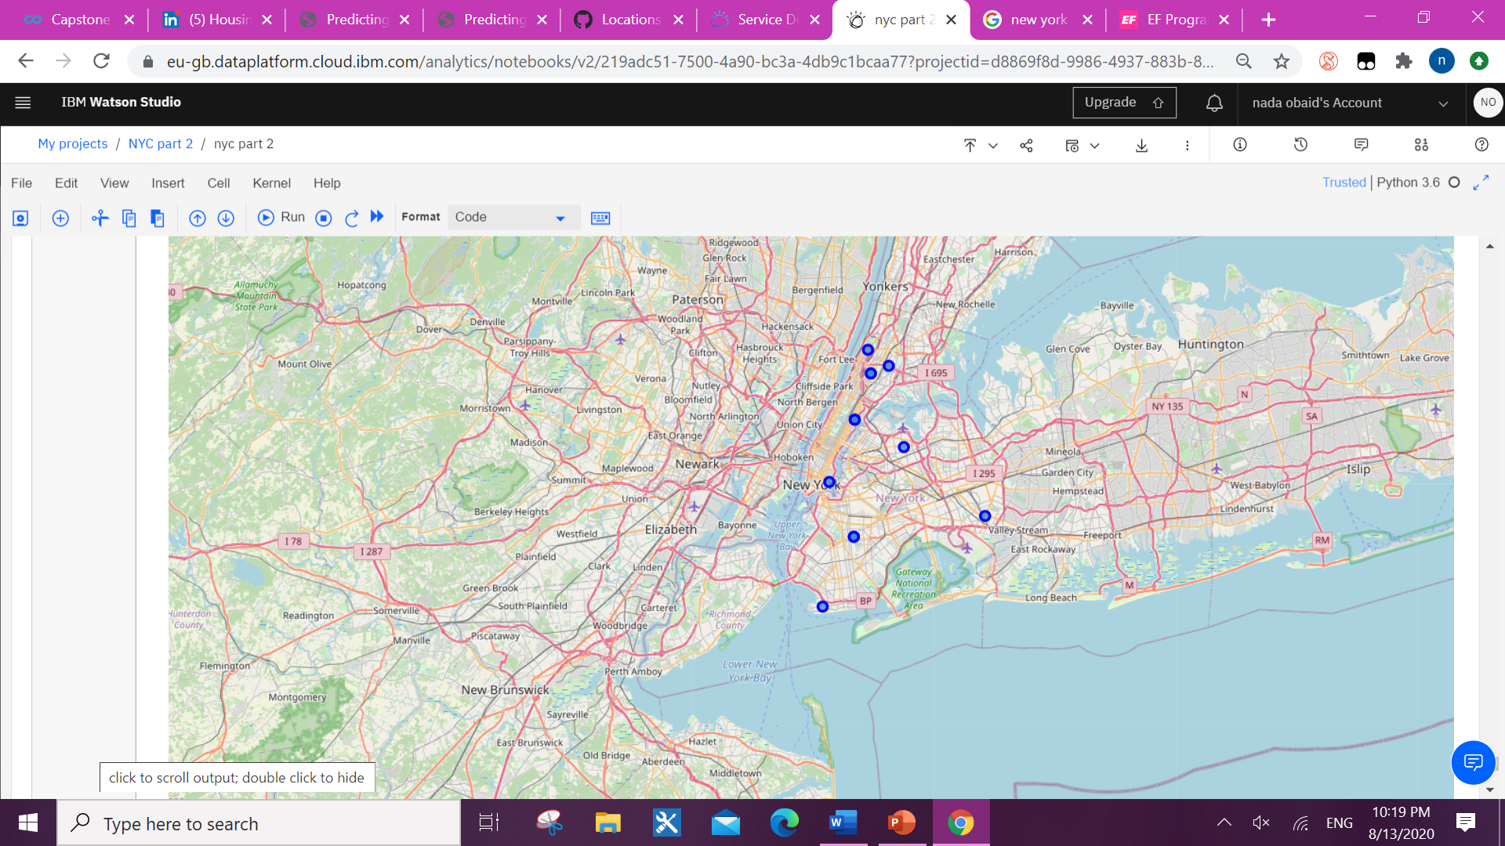

**6. Conclusion:**

As a result, investors whom are willing to start a community pharmacy business can achieve better outcomes through their access to platforms where such information are provided. No matter how hard to find the proper data to study and to analyze it is a crucial step to find the best location for your successful future business.

**7. References:**

1. "World Urban Areas" (PDF). Demographia. 2018. Retrieved March 27,2018.. <https://en.wikipedia.org/wiki/New_York_City#cite_note-12>
2. Lester Nathan, MS in Pharmacy times journal-2015-09-14 <https://www.pharmacytimes.com/contributor/lester-nathan-ms/2015/09/how-to-pick-the-best-pharmacy-location>
3. NYC Health + Hospitals patient care locations -updated July 3, 2019

<https://data.cityofnewyork.us/Health/NYC-Health-Hospitals-patient-care-locations-2011/f7b6-v6v3>